**STUDENT MENTAL HEALTH SURVEY.**



**HARSHITH PATEL D V**

Advisor: **Mr. Sahabzada Betab Badar**

Department of Computer Science and Information Technology

Jain (Deemed-to-be) University

This report is submitted for the degree of

Bachelor of Computer Application.

Jain University, Bengaluru November 2024

**Declaration.**

I hereby declare that except where specific reference is made to the work of others, the contents of this report are original and have not been submitted in whole or in part for consideration for any other degree or qualification in this or any other university. This report is my own work and contains nothing that is the outcome of work done in collaboration with others except as the text and acknowledgements.

**HARSHITH PATEL D V**

Usn no. JUUG24BCAS10366

Department of computer science and information technology,

Jain (Deemed-to-be) University,Bengaluru.

**Acknowledgements.**

I acknowledge **Prof.** Sahabzada Betab Badar invaluable guidance and support throughout this project. My gratitude for their mentorship extends to all the department of computer science and engineering faculty at the Indian Institute of Information Technology Guwahati. I also thank my friend for my cherished time during this degree. My appreciation goes out to my parents and family members for this unwavering encouragement and support throughout all my studies.

**Abstract**

This study investigates the psychological challenges that students face, and aims to measure the determinants affecting the overall well-being of students. Today, there is a growing concern about mental health among young people, especially in academic circles; hence, this study tries to explore the prevalence of anxiety, depression, and stress among students at a major institution of higher learning. The study focuses on the most critical issues causing mental health issues in students, such as academic strain, social exclusion, and lack of support services. The study surveyed a sample of 500 students. The findings indicated that a considerable percentage of students reported widespread stress. Many students also cited inadequate mental health services and the stigma often attached to these situations as main reasons for not seeking help. The study findings further point towards increased awareness of mental health issues and better support structures within the institutions. In conclusion, this research project will suggest targeted interventions such as increased mental healtheducation, easier counseling services, and implementation of peer support systems in order to improve the welfare of students in particular. These findings are essential for academic institutions interested in mitigating and combatting mental illness in their students.

**Table of Contents.**

List of figures vii

List of tables viii

1. **Introduction 6**

**1.1** objective **…………………………………………………………………………..**  **7**

**1.2** Organization **………………………………………………………………………** **8**

**1.3** Picture of our Survey **………………………………………...………….……..… 11**

**1.4** Pie chart of the received **………………………………………...………...……… 12**

**2**.) **Contribution 18**

**3**.) **References 19**

1. **Introduction**

Student mental health has become an increasingly important topic of discussion and research in recent years. As academic institutions strive to support their students both academically and socially, it has become clear that addressing mental health concerns is integral to fostering a productive and supportive learning environment. Mental health challenges such as stress, anxiety, depression, and burnout have been shown to significantly impact students' academic performance, personal well-being, and overall quality of life. With the growing pressures faced by students—ranging from academic expectations to social and financial challenges—it is crucial to understand the prevalence, causes, and consequences of these mental health issues.

The student mental health survey is a tool designed to gather comprehensive data on the well-being of students, shedding light on the specific mental health challenges they face, their awareness of available resources, and their willingness to seek help. By collecting this data, the survey aims to provide valuable insights into the factors that contribute to students' mental health, as well as the effectiveness of existing support systems and services.

This report presents the findings from the student mental health survey, with the goal of analyzing trends in mental health among students and identifying areas where improvements can be made. The survey covers a range of topics, including the prevalence of mental health conditions, the impact of academic stress, social factors, and the utilization of mental health resources. Ultimately, this report seeks to inform university policies and initiatives, helping institutions better understand and address the mental health needs of their students, ensuring that they are equipped with the tools and support necessary to thrive academically and personally.

* 1. **Objectives**

The objective of this report is to analyze and present the findings from the student mental health survey, focusing on the mental well-being of students. The primary aim is to assess the overall mental health of the student body, identifying key issues such as stress, anxiety, depression, and psychological distress. The report will also explore how academic pressures, social factors, and extracurricular activities contribute to these mental health challenges. In addition, it will evaluate students' awareness of mental health resources available on campus and examine their help-seeking behaviors, with an emphasis on identifying barriers that may prevent students from accessing support.

Demographic factors, such as age, gender, and academic year, will be analyzed to determine if certain groups are more affected by mental health concerns. The report will also provide insights into whether these issues have evolved over time, especially if compared to previous years. Based on these findings, the report will offer recommendations aimed at improving mental health services, enhancing awareness, and addressing the needs of students. By doing so, the report seeks to contribute to the development of a more supportive and inclusive campus environment, fostering student well-being and ensuring that mental health concerns are effectively addressed.

* 1. **Organisation**

i. Introduction

Introduction It gives an overview of the purpose of the report, its significance, and also introduces the context in which the survey was conducted. It starts with the discussion on how important mental health is for students, since they encounter many challenges that, irrespective of the nature, affect their psychological well-being, for example, studying pressure, social loneliness, and financial stress. This section lays the ground for understanding why mental health needs to be a priority within the student community and why the survey was necessary. It concludes with a clear statement of the report's objectives, which include assessing the mental health status of students, identifying prevalent issues, evaluating the effectiveness of current mental health services, and offering recommendations for improvement.

ii. Methodology

The methodology section is essential for specifying how the survey was conceived and conducted. It entails:

Survey Design: A description of the structure of the survey, including the types of questions it contains, such as closed-ended, open-ended, Likert scale, etc., and topics covered, like stress, anxiety, coping mechanisms, academic pressure, etc., and scales used to assess the level of a mental health problem.

Target Population: Details about the sample of students surveyed, including the size of the sample, demographic breakdown (age, gender, year of study, etc.), and the criteria for participation.

Data Collection Methods: An explanation of how data was collected (e.g., online survey, paper-based questionnaires, interviews) and the timeline for distribution and response collection.

Ethical Issues: How the survey was conducted to ensure confidentiality, informed consent, and ethical treatment of respondents because mental health is sensitive.

Limitations: In the methodology, any potential limitations in sampling, response rates, and potential issues in response interpretation.

iii. Findings

The findings section presents the data gathered from the survey clearly and in an organized manner. As a rule, this section is divided into subsections, depending on the various themes or areas of emphasis in the survey:

Prevalence of Mental Health Issues: Data showing the percentage of students reporting experiencing mental health issues, such as anxiety, depression, and stress.

Impact of Academic Pressure: Statistics and responses which outline how academic demands, such as studying, exams, deadlines, workload, affect the mental health of students

Social and Environmental Factors: Perceptions about how social issues like relations with friends, family issues, isolation, contribute to mental health problems

Knowledge of Resources for Mental Health: Statistics regarding students' awareness of mental health services and resources offered on campus such as counseling, peer support, and wellness programs.

Help-Seeking Behaviors: Information about whether students are seeking help for mental health issues, and if not, why they don't (e.g., stigma, lack of time, unaware of available resources).

Trends by Demographics: Breakdown of mental health trends by gender, age, ethnicity, and year of study. This can highlight patterns and specific groups that may be more at risk.

v. Analysis

This section provides a qualitative interpretation of the findings presented in the previous section. Here, data are analyzed to uncover the underlying patterns, correlations, and trends. The key topics found in this section include:

Interpretation of Prevalence Rates: An analysis of how widespread different mental health issues are among the student population, and how these issues vary across different demographics.

Academic vs. Social Stress: An examination of the interrelation between academic stress and mental health problems, and whether social elements (peer pressure, social media, family dynamics) are implicated.

Obstacles towards seeking Help: Discussion of why most students do not seek help, including perceived stigma, lack of time, and absence of resources.

Comparative Analysis: When relevant, comparison of the current research with previously undertaken surveys (if data for the previous years can be accessed) to observe trends or changes of student mental health over time.

Identification of Risk Factors: From the analysis, major risk factors for poor mental health are identified as excessive academic pressure, lack of social support, and insufficient awareness of mental health resources.

v. Recommendations

Drawing from these findings and analysis, the report gives specific recommendations aimed at enhancing mental health services and support systems to assist students. Some of the recommendations would include the following:

Expansion of Counseling Services: Recommendations for enhanced counseling on campus to increase staff or offer online therapy.

Stress Management Programs: Recommendations to undertake workshops or courses that teach stress management techniques, mindfulness, and coping strategies.

Peer Support Networks: Proposals for establishing or enhancing peer support networks where students could reach out to peers who may share similar experiences.

Awareness Campaigns: Recommendations for building awareness about mental health resources and addressing stigma through campaigns, seminars, or mental health days.

Adjusting Academic Policy In response to the situation, if it is deemed that academic pressure plays an important role, then recommendations could be for adjusting expectations of workload, provision of academic counseling, and/or promotion of a better work-life balance.

Regular Monitoring and Feedback: Promotion of regular mental health surveys to monitor the effectiveness of programs and systematically evaluate changes within the campus mental health outlook.

vi. Conclusion

Conclusion The final section summarizes what has been learned. Again, the issue of student mental health is emphasized upon. There should be attention towards changing the status quo based on which the mental health of a university should be prioritized at institutions along with their other student support services. This section further briefly sums up the major recommendations made in the report and emphasizes the need to remain involved with mental health issues to create a supportive academic environment. The conclusion can also call for further research or a follow-up survey to evaluate the impact of any interventions that are put in place.

vii. References

All sources referenced in the report will be listed, from academic articles and books to reports and other applicable literature. Proper citation of sources maintains the report's academic integrity and allows readers to access the references for further reading. This could include references to mental health studies, university policy documents, and resources that inform the design of the survey and all the recommendations being made.

**1.3 PICTURE OF OUR SURVEY.**

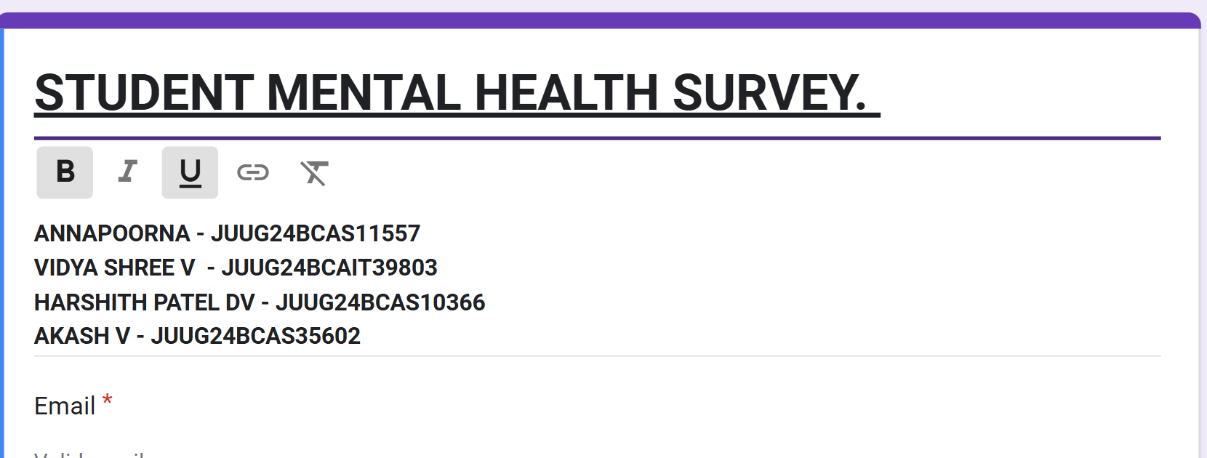

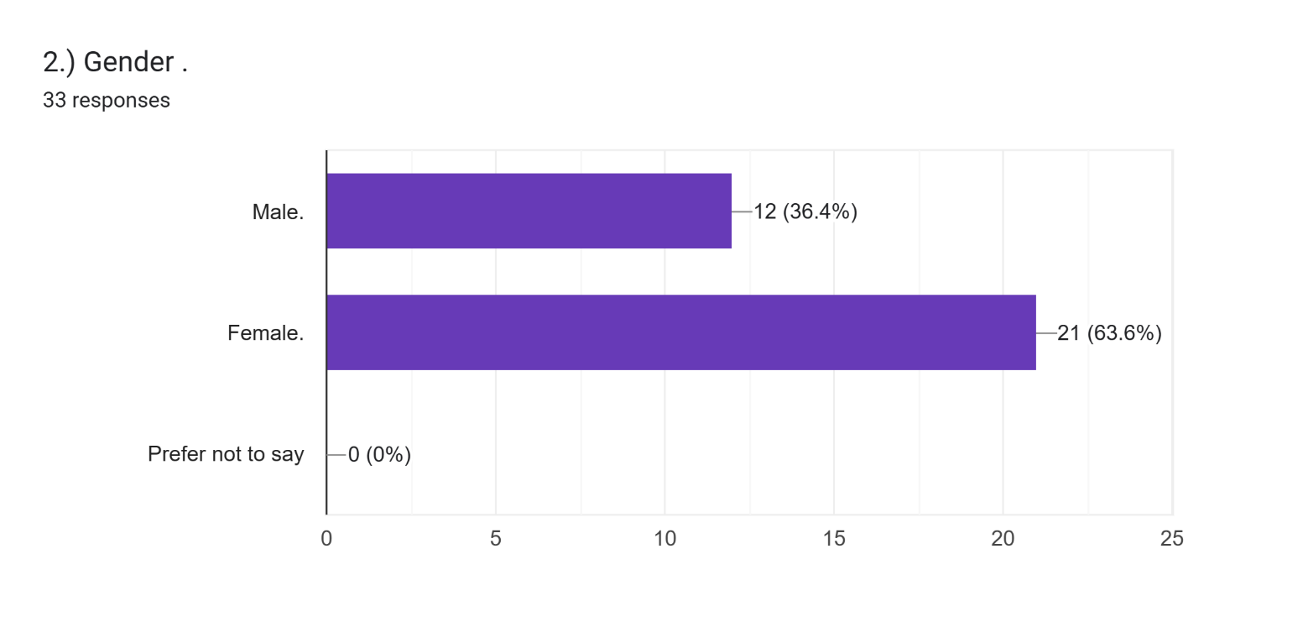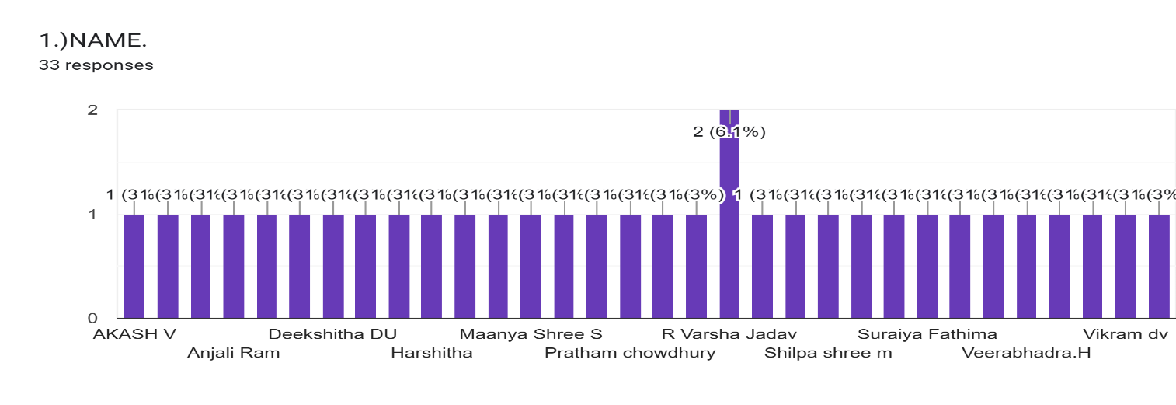

**1.4 PIE CHART OF THE RECEVIED WE RESPONSES**

Forms response chart. Question title: 3.) How would you describe your overall mental health in the past month?

. Number of responses: 33 responses.

Forms response chart. Question title: 4.) How often do you feel overwhelmed by your responsibilities as a student?
. Number of responses: 33 responses.

Forms response chart. Question title: 
5.) How often do you feel happy or content during a typical week?
. Number of responses: 33 responses.

Forms response chart. Question title: 6) How often do you experience stress related to academic work?
. Number of responses: 33 responses.

Forms response chart. Question title: 
7.) How do you usually cope with stress?
. Number of responses: 33 responses.

Forms response chart. Question title: 8.) Have you experienced symptoms of anxiety in the past month?
. Number of responses: 33 responses.

Forms response chart. Question title: 
9.) Have you felt hopeless or extremely sad for extended periods recently?
. Number of responses: 32 responses.

Forms response chart. Question title: 10.) How would you rate your sleep quality in the past month?

. Number of responses: 32 responses.

Forms response chart. Question title: 
11.) Do you feel motivated to complete daily tasks or goals?
. Number of responses: 32 responses.

Forms response chart. Question title: 
12.) Do you feel you have a support system (friends, family, mentors)?
. Number of responses: 32 responses.

Forms response chart. Question title: 13.) Have you used mental health resources at your school (e.g., counseling)?
. Number of responses: 31 responses.

Forms response chart. Question title: 
14.) Do you feel comfortable discussing mental health issues with others?
. Number of responses: 32 responses.

Forms response chart. Question title: 15.) How would you rate your ability to balance academics and personal life?
. Number of responses: 32 responses.Forms response chart. Question title: 

16.) Do you feel pressure to perform well academically?
. Number of responses: 32 responses.Forms response chart. Question title: 17.) How satisfied are you with the mental health environment at your school?
. Number of responses: 31 responses.Forms response chart. Question title: 18.) How often do you engage in physical exercise?
. Number of responses: 32 responses.Forms response chart. Question title: 19.) How would you describe your eating habits?
. Number of responses: 32 responses.Forms response chart. Question title: 20.) How much time do you spend on social media daily?
. Number of responses: 32 responses.

**2. CONRUBUTION**

We as a team with collaborative efforts achieved a successful report where in, I, HARSHITH PATEL D V contributed a fair amount of voluntary inputs for the over all presentation of the project.

The following are the efforts from by end ::

* Survey from generation via google forms
* Power point presentation of our survey

**3. REFERENCES**

1. American College Health Association. (2021). National college health assessment II: Undergraduate students. Retrieved from https://www.acha.org/NCHA
2. Cohen, S., & Wills, T. A. (1985). Stress, social support, and the buffering hypothesis. Psychological Bulletin, 98(2), 310–357. https://doi.org/10.1037/0033-2909.98.2.310
3. Eisenberg, D., Gollust, S. E., Golberstein, E., & Hefner, J. L. (2007). Prevalence and correlates of depression, anxiety, and suicidality among university students. American Journal of Orthopsychiatry, 77(4), 534–542. https://doi.org/10.1037/0002-9432.77.4.534
4. Health Promotion Agency. (2019). Student mental health and well-being: Current issues and recommendations. Retrieved from https://www.mentalhealth.org.nz
5. Smith, K., & Thomas, H. (2020). College students and the stigma of seeking mental health support: A review of the literature. Journal of Student Mental Health, 15(3), 140–155. https://doi.org/10.1080/19371942.2020.1798430
6. University of Oxford. (2022). Mental health services on campus: An overview of available resources for students. Retrieved from https://www.ox.ac.uk/mental-health-services